

**HealthTrust Europe LLP: ITT to establish a framework agreement for consultancy solutions and advisory services Contract Notice (FTS) Ref: 2023-041574**

**Technical Response – C1_Value for Money_Ethical Healthcare Consulting**

C1: Please explain how you will ensure value for money for Participating Authorities. Your response should include:

• how appropriate consultants are allocated depending on seniority and experience given the nature and demands of a project;

• how budgets are managed;

• how the most appropriate approach for the project in question will be provided and provide an example; and

• confirmation on how you will take an economical approach to a project with a focus on value for money but without compromising on quality.

**EHC Response:**  
  
**• how appropriate consultants are allocated depending on seniority and experience given the nature and demands of a project;**

EHC has a core, permanent team complemented by a wider team of associates providing us with over 100 resources. This team can be deployed in a flexible, scalable way, with our permanent team primarily operating as the delivery element of projects, ensuring a consistent, high level of quality and adherence to best practice.

Fulfilling resource requirements for varying project roles:

EHC will co-design an operating model with the Project team; agreeing standard operating procedures, a prioritisation framework for allocations, and a single point of contact for support requests. EHC’s internal PMO will review requests, and co-design work packages. The EHC operations team source the best available and skilled resources at the right time to fulfil the agreed outcomes, accessing the team of associate and permanent resource. With Project team, we will co-design a framework for resource allocation using an assessment of risk. Our operations team will monitor and forecast demand, working with Project team and proactively engaging THE Project team and EHC programme leadership.

Our model ensures access to a wide supply of resources to identify the best available practitioners for each type of work package including:

* Digital transformation business-case writing and development

Multiple senior and experienced associates who have contributed to our 100% track record in securing approval for the business cases we have authored

* System configuration /System experts

Market leading technical experts encompassing a varied blend of technical, business, enterprise, data, application, infrastructure and network architects with experience of the vast majority of clinical and corporate systems the Project team currently in use within the NHS

* Business Change / analysis

Broad capability across change, technical, data and user design focused specialists with extensive experience in delivering successful digital transformation programmes

* Procurement

EHC have a strong roster of finance specialists including former “big 4” trained accountants, former NHS Finance professionals and commercial modelling subject matter experts. EHC also partner with Realm Partners who add to our commercial and procurement capability

* Project Management

Deep and broad capability across numerous associates and permanent staff with track records and reputations for successfully delivering projects and programmes within the NHS over the last 30 years.

* Training

Significant experience in developing and delivering training strategies and programmes, as well as deploying an innovative, User Centric Designed approach.

* Testing

There is a strong track record in delivering successful testing workstreams within EHC Associates, from initial set up to implementation of live product. This includes:

* Identification & formation of testing team
* Assembly of testing laboratory (or online equivalent)
* Production of ‘Test Strategy’ and ‘Test Plan’
* Authoring of complete set of test scripts, in line with future state business processes
* Cataloguing and change control of all test scripts through duration of the testing cycles
* A ‘Local Build’ test cycle (LBT) to assure that the system configuration is in line with future state business processes
* A set of ‘User Acceptance’ test cycles (UAT) with appropriate development time in between (usually 2 cycles)
* During each test cycle, all test scripts will be run in a controlled environment with full documentation of software builds, log ins used, role-based user access (RBAC) etc
* Issue management during each test cycle. Logging of all issues found, with minimum data set requirements in place
* Daily wash up calls to report on testing progress and any issues discovered
* End of test cycle review and written report, with testing statistics and proposed issue resolutions
* Escalation of all ‘showstopper’ issues, and documentation of reasoning and risks (including clinical safety, system reliability, reputational etc)
* All test scripts to be verified and amended (if necessary) between test cycles
* Sign off successful testing after final UAT. Any remaining issues to be documented and signed off, with confirmed workarounds in place where appropriate
* Any necessary hotfixes prior to go live to be tested, documented, and signed off
* To be fully involved in any dress rehearsal(s), completing and documenting touch testing as part of the process
* To be fully involved in cutover, completing and documenting touch testing ahead of go live. Providing confirmation of go/no go
* Clinical knowledge/subject experts/Clinical safety officer

The EHC team of associates includes multiple clinical representatives; CCIO, ex-CNIO, Clinical safety leads and the first former Digital Chief Nurse for the NHS.

* Technical Architecture

EHC have a range of technical expertise with a range of ex-supplier and NHS experience. EHC have extensive experience working with NHS England advising on a region level and providing expertise to a number of NHS trusts.

* Integration / Migration

EHC have exceptionally strong capability to deliver interoperability and integration architecture and strategy as well as Data management / Migration / warehousing strategies. EHC partner with Egress Group who provide integration capacity and capability and a market leading migration toolkit and methodology.

EHC ensures resource availability across various projects without compromising quality. Our scalable team extends across the following areas with associated volumes:

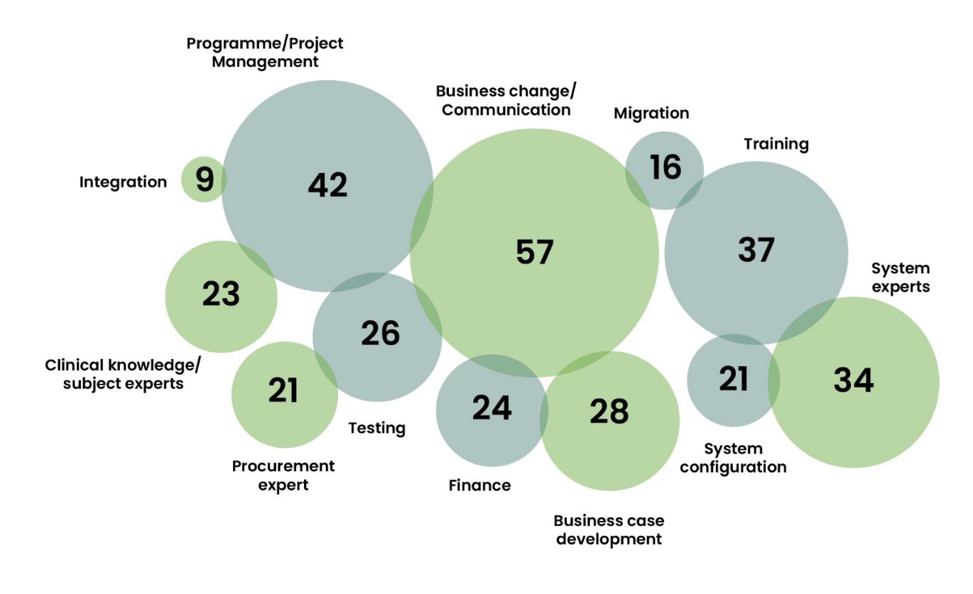

**• how budgets are managed;**

It is the role of EHC delivery managers, to manage costs, assess and review risks and identify issues. To ensure there are appropriate mechanisms to manage this, EHC has processes and training in place for all of our delivery managers as part of our delivery playbook to ensure budget review and risk management is completed consistently.

CMAP is a resource management and scheduling tool used to forecast and manage project resources effectively. It enables delivery managers to identify future resource requirements and manage costs efficiently. CMAP provides a clear view of budget implications, assisting delivery managers in making informed decisions, including forecast forward scheduling. This assists our teams to proactively manage the team allocations and associated budgets, real time allowing for quick corrective actions, such as adjusting resource schedules or addressing additional costs arising from unforeseen issues, which may require us to instigate the contingency process.

Appropriate governance is implemented at the very start of the project by the delivery manager. All EHC projects have a senior responsible officer (SRO) allocated. Additionally, the delivery manager would ensure counterparts on the client side also have the equivalent governance in place to ensure appropriate escalations can take place with the respective SROs.

EHC has significant experience in tracking individual projects and programmes of work to ensure they are delivered on time and to budget.

Our rigorous PMO approach to programme and project delivery with a comprehensive tailored toolset to support the approach affords us the ability to see at a glance progress across their programme of work against the budgeted total.

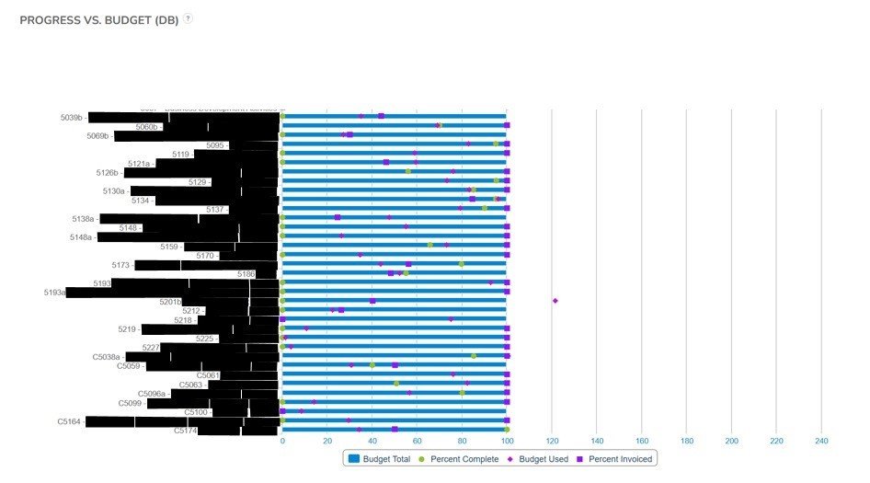

Using EHC’s PMO toolkit, each project tracks actual against budgeted spend and resource utilisation including project progress:

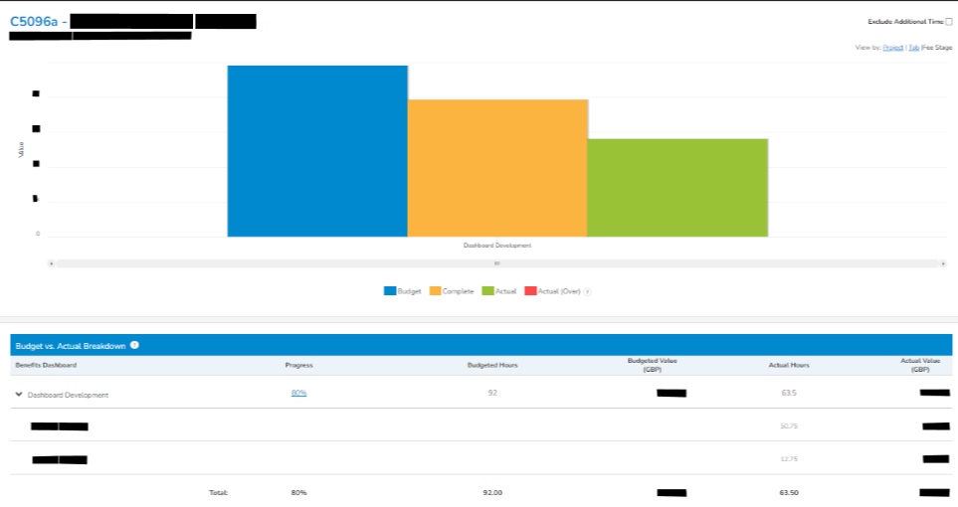

The PMO toolkit also can track resource utilisation against each project and against key project milestones. Any deviations from expectations are managed through weekly reporting and meetings. These measures inform the delivery team of expected progress and ensure project are streamlined, on time and to budget. More information on the tools available within the EHC PMO toolkit can be found within our supporting documents ‘***SD18 PMO Toolkit***’.

Identification of additional costs are done in various ways. The delivery manager is responsible for running stands up, show and tells and retrospective sessions. Within these different forums the delivery manager will review the risks and potential challenges which could impact the budget. This is review and flagged immediately with appropriate mitigations and communications in place.

EHC's experience with Surrey and Borders Partnership NHS Foundation Trust (SABP) serves as a pertinent example. In this project, we experienced scope expansion which meant that unforeseen additional time was required by our technical team, therefore increasing costs. A risk relating to scope creep was identified early in the project, which afforded us the ability to set a contingency to cover some aspects of the technical work required. In line with our commitment to transparency and values, EHC engaged in open discussions with SABP, reaching an agreement where the additional costs were agreed, mutually acknowledged and a reprioritisation of resources completed to enable project delivery. The risk contingency enabled us to focus on the positive outcome and share the risk with the client.

Another instance of managing unforeseen costs was during our work with NHS England on a SE data-sharing strategy. EHC proactively identified budget constraints as a potential risk at the project's inception. To maintain client awareness and manage this risk, EHC provided bi-weekly budget reports and emphasised the value delivered against the budget. Progress was transparently demonstrated through regular show-and-tells. Furthermore, risks were frequently reviewed, and additional measures like highlight reports were implemented to ensure complete transparency with the client.

**• how the most appropriate approach for the project in question will be provided and provide an example;**

EHC employ agile processes to deliver programmes where appropriate, and a key element of this is the initial mobilisation and governance phase which defines appropriate governance and ways of working for the programme. This includes embedding socialisation and sign off mechanisms with the Project team to ensure the direction of travel of the project or programme remains in alignment with our clients' requirements.

In our EHC delivery framework, a "Sprint 0" is included for thorough planning. This phase involves stakeholder engagement and scope reconfirmation, setting a solid foundation for successful project mobilisation and execution.

EHC employs a strategic approach to manage and scale multiple projects efficiently. Our initial step is to define each project’s scope and identify key stakeholders.

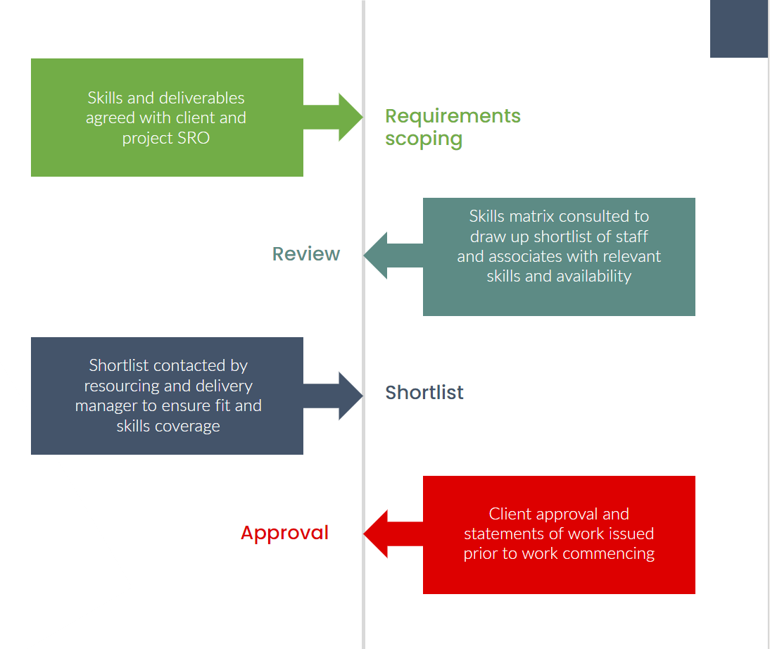

The process begins with a review and harmonisation phase, assessing organisational priorities and needs. For instance, in a recent deployment involving multiple organisations, EHC evaluated platform contracts to identify cost savings and service agreements. This included strategic planning for contract expiration timelines and inter-organisational support, starting with the most complex yet time-sensitive Trust.

Our methodology involves managing multiple workstreams within large programs to prevent duplication of efforts. This includes teams supported by clinical expertise, a central team for building core solutions, and localised workstreams for specific trust requirements like integration and data migration.

An example of this is working with our client, Surrey and Borders Pathology (SABP), where we had multiple workstreams including building a technical alpha solution, business case and communications. Our approach with SABP was to take an Agile approach and focus on the key tasks that were required by the client. However, we found that when working with the client the business case workstream needed to adapt to a waterfall methodology to demonstrate the dependencies and impact on timescales based on lack of engagement and the ability to turn around responses for the business case. Within this scenario we had taken a Wagile approach to accommodate the communication and alpha build workstreams to ensure we deliver the clients project in the most effective way.

**• confirmation on how you will take an economical approach to a project with a focus on value for money but without compromising on quality.**

EHC ensure value for money on all projects by focusing on maximising both efficiency and value delivered. Approaches to optimising efficiency include reuse of standardised best practices templates and approaches, with no custom approaches taken unless required and appropriate. EHC have fully standardised delivery lifecycles and methodology in place, constantly updated and finessed under continual quality improvement based on our delivery data. Lessons learned workshops are held at the end of all our engagements.

As well as being able to field some of the most competent and experienced individuals within the global healthcare market, our clients also tell us that they work with us because EHC live and work by our values. These are:

* Equality and equity – EHC are never exploitative.
* Integrity – EHC always act in line with our values and morals.
* Happiness - EHC strive to make our clients, our colleagues and ourselves happy in our work and lives.
* Honesty and Transparency – EHC are always open and honest and are fully transparent in everything EHC do.
* Compassion – EHC look for the best in all situations and people and are generous in giving our support.

EHC have impact at the very core of our organisation, it is our reason for being. EHC have several examples where engagements have been declined because the scope was not within our skillset and would not have represented value for money. EHC monitor and improve impact and added value through monitoring data points, for example, CSAT. The social impact of EHC’s work and organisation is measured using [Loop](https://loop.org.uk/) impact tracking software. EHC have recently partnered with Newcastle University, engaging a full-time resource to help measure and optimise the value which EHC add to the NHS. The value optimisation starts ahead of engagement commencement, in applying the most appropriate resources to the work. The team are profiled using the SFIA skills framework, along with knowledge of which individuals have a track record of successful co-working. These are combined to ensure that clients get the right people for the right job.

There are demonstrable examples of refunding surplus funds to clients where we have delivered under budget.

In summary, EHC’s delivery is optimised through standardisation and data-led continual quality improvement. EHC are unique in our approach of continually measuring our impact, value add and customer satisfaction, and deliver under budget, refunding or repurposing surplus funds to clients.

EHC’s approach to partnering is to provide a fully tailored and flexible service which meets the needs of the client within their defined budget. Skills and expertise are deployed based on need under an agreed monthly or annual budget, ensuring the client only pays for what they need at the right time, at the right cost. This focus enables organisations to avoid the pitfalls associated with major programmes by ensuring they have access to the right knowledge that will help them to get it right first time. EHC support organisations throughout major transformation programmes by providing access to a pool of specialists whose experience, expertise and knowledge allow their clients to leverage the learning of their extensive capability and skill set, within a manageable cost envelope. Typically, EHC will complete a fixed price discovery phase, the output of which will be to outline a proposed call-off based resource pool (which can be expanded and condensed as required) and a suggested allowance of days during the course of the engagement so as to align with the agreed budget.

This resource effort is completely flexible, with peaks and troughs accounted for over the lifecycle of the service though a monthly or quarterly true-up of effort expended against budget. Where additional resource of separate resource is required outside of the proposed core pool, effort and costs will be agreed in advance on an ad-hoc call off basis as the partnership develops and in line with the agreed budget.

The suggested resource profile will cover a variety of skill sets and capabilities, however the Project team will have complete freedom to utilise (or not utilise) specific resources as they see fit, either within the agreed budget or outside of it should there be a need to expand funding.

If the resource demand does not meet the agreed budget, EHC will not charge any more than is required to deliver the required utilisation of resource.

EHC operate in an entirely transparent way, and ensure our clients are keep completely informed on how budget is being spent. This entails a number of internal processes to ensure EHC are able to balance our open book approach with the maintenance of ethical walls. This includes;

* Detailed policies outlining our commitment to open book principles and ethical walls are key components of our employee and associate contracts.
* Training sessions for our staff to ensure they understand the importance of open book principles and ethical walls within EHC
* EHC has detailed processes for financial reporting, cost breakdowns, and disclosure of relevant information. This includes clear guidelines on how to handle sensitive information and maintain ethical walls.
* EHC implement access controls to ensure that only authorised personnel have access to sensitive financial and contractual information, and we clearly define roles and responsibilities within the organisation regarding the handling of sensitive data.

Demonstrating value

* From the outset we will use our internal skills profiles and resource management to ensure we provide the optimal team to deliver value. This team will be reviewed throughout the engagement to ensure this remains the case.
* We will continually track cost, scope and value add during the project, all of which are a core and fundamental function of our PMO function. This data will be completely transparent and accessible to the Project team on a weekly basis.
* We will track client satisfaction at regular checkpoints throughout the engagement.
* Critically, we will take action based on a combination of the above as and when appropriate, to ensure optimal value for money.

EHC commits to ensuring value for money in all projects by maintaining efficient operational practices and cost-effective resource allocation. Our overheads, as per the last year's (22/23) statutory accounts (2022/23), stood at 20.1%.